**APPLICATION FOR THE SUITABLE POST**

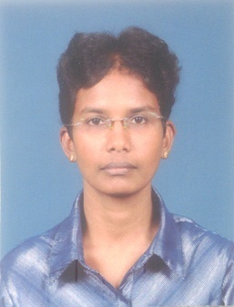WITHANAGE DAMAYANTHI KUMARI

NO: 45,

HENGODA,

KUDA UDUWA,

HORANA.

071 9393273, 0774744850, 0729793193

E-mail :- [damayanthikumari29@yahoo.com](mailto:damayanthikumari29@yahoo.com)

**PERSONAL DETAILS**

Name with Initials :- Withanage Damayanthi Kumari

Date of Birth :- 14th .03.1977

National I.D.No. :- 775741740V

Sex :- Female

Civil Status :- Single

Religion :- Buddhism

School Attended :- K / Taxila Central College - Horana.

**EDUCATIONAL QUALIFICATIONS**

G.C.E.(O/ L ) Examination - 1993

**Subject Grade**

Buddhism D

Sinhala C

Mathematics C

English C

Social Studies C

Home Science C

Science S

G.C.E.(A/ L ) Examination - 1996

**Subject**  **Grade**

Sinhala B

Economics C

Buddhist Culture C

History C

**PROFESSIONAL QUALIFICATIONS**

**PROFESSIONAL QUALIFICATIONS**

 I have Followed the certificate in MS- Office Course at I.R.E.T.Computer Training

Center – Panadura.

 Also Followed Desktop Publishing Course at Wijaya Computer School -Horana.

 I have followed a English Diploma Course at National Youth Centre -

Maharagama.

**WORKING EXPERIENCE**

1. Worked at the Wimalasiri Stores (Pvt) Ltd, as a Computer Operator nearly 4 Years.

II. I have worked as a Sinhala & English Typesetter for 3 years.

1. I have worked as a Computer Operator at Beam Chemicals (Pvt) Ltd. about 2

years.

**OTHER QUALIFICATIONS**

 I have followed a Announcing Course under Mr. Dharma Sri Wickramasinghe.

 I had participated for Co-ordinating programmes in City F.M.

 I write articals for Cinees Art Paper.

* I am following Photographic course in The National Photographic Art Society Of Sri Lanka.

**NON –RELATED REFEREES**

Mr. Indima Kanattawatta, Mr. Narada Jinasena

Computer Lecturer, English Lecturer

Youth Center, 0716400653

Meewanapalana.

077 6006262

I certify that the above particulars are true and correct to the best of my knowledge.

........................................... ...............................................

Date Signature of Applicant

Mr **mMr**